AWTL PA2

Mithil Shinde

2213681

MITU21BTCS0330

Exp 11- Convert an existing static website to a responsive one using Bootstrap.

Output-

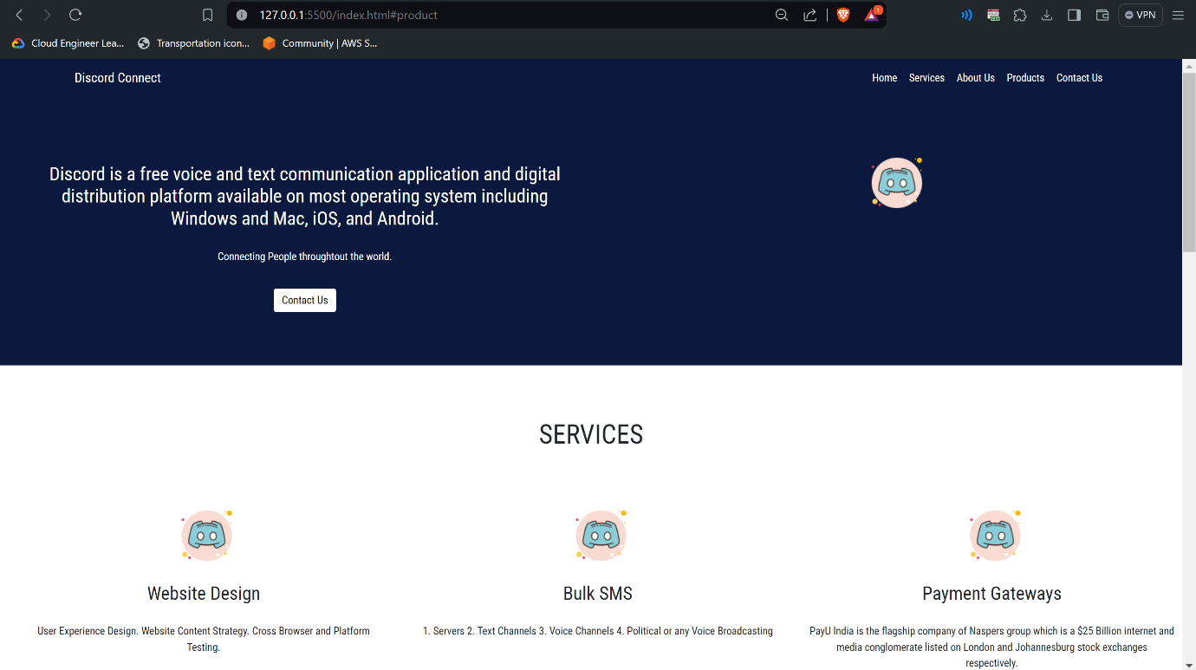

Link-